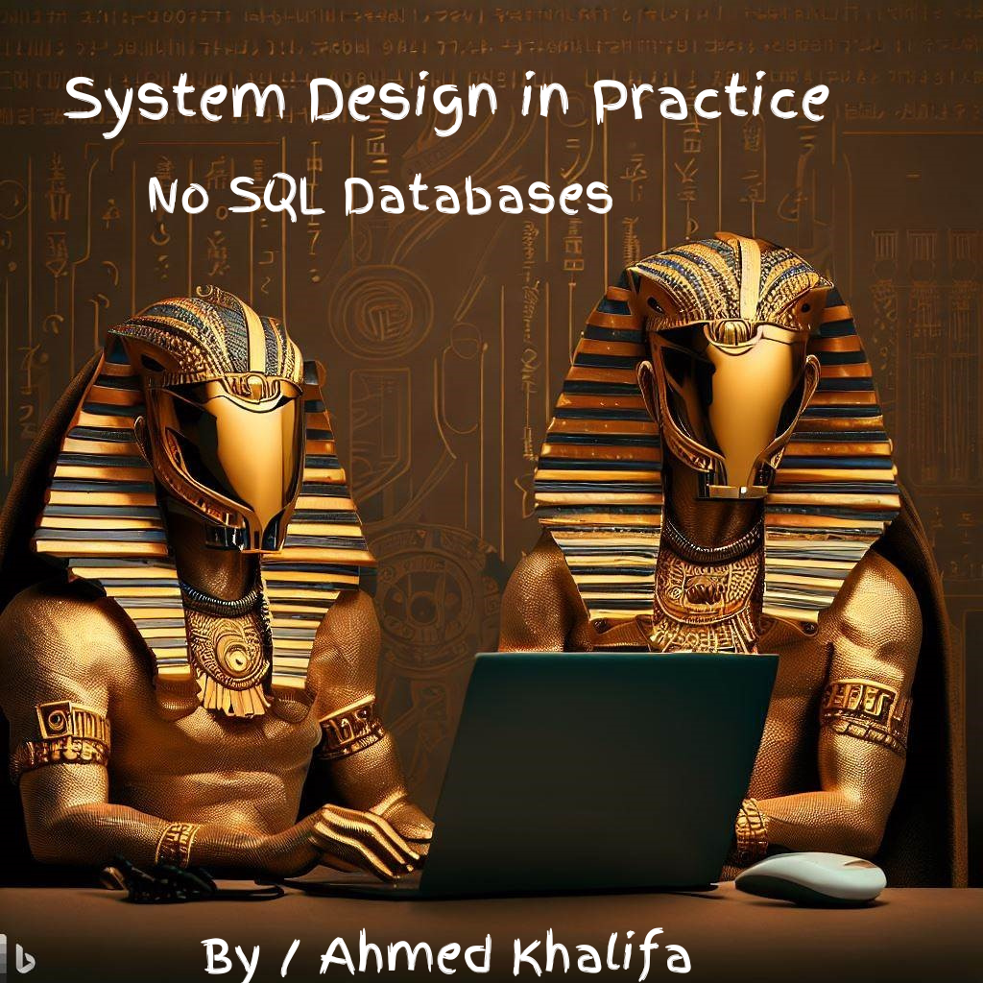

**Index**

1. Technology agnostic
2. What are SQL Databases ?
3. What are NO SQL Databases ?
4. SQL VS NO SQL Databases
   1. Data model :
      1. Structure data model
      2. Semi structure data model
      3. Unstructured data model
   2. Database Language  
        
      4.2.1 Standard language   
        
      4.2.2 Complex query

4.3 Scalability

4.3.1 Vertical scalability

4.3.2 Horizontal scalability

4.4 Consistency and concurrency model  
  
 4.4.1 Strong consistency   
  
 4.4.2 Causal consistency   
  
 4.4.3 Eventual consistency   
  
 4.5 Theorem and principles   
  
 4.5.1 ACID   
  
 4.5.2 CAP